# Step 1: Create a Launch Configuration

A launch configuration specifies the type of EC2 instance that Auto Scaling creates for you. You create the launch configuration by including information such as the Amazon Machine Image (AMI) ID to use for launching the EC2 instance, the instance type, key pairs, security groups, and block device mappings, among other configuration settings.

**To create a launch configuration**

1. Open the Amazon EC2 console.
2. In the navigation pane, under **Auto Scaling**, click **Launch Configurations**.
3. Select a region. The Auto Scaling resources that you create are tied to the region you specify and are not replicated across regions..
4. On the **Welcome to Auto Scaling** page, click **Create Auto Scaling group**.

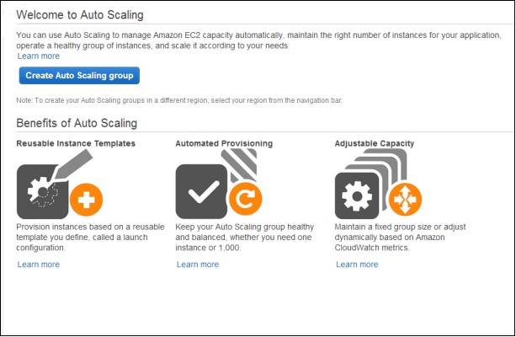

1. On the **Create Auto Scaling Group** page, click **Create launch configuration**.
2. On the **Choose AMI** page displays a list of basic configurations, called Amazon Machine Images (AMIs), that serve as templates for your instance. Select the 64bit Amazon Linux AMI.
3. On the **Choose Instance Type** page, select a hardware configuration for your instance. We recommend that you use the t2.micro instance that is selected by default. Click **Next: Configure details**.
4. On the **Configure Details** page, do the following:
   1. In the **Name** field, enter a name of your launch configuration (for

example, my-first-lc).

* 1. Under **Advanced Details**, select an IP address type. If you want to connect to an instance in a VPC, you must select an option that assigns a public IP address. If you want to connect to your instance but aren't sure whether you have a default VPC, select **Assign a public IP address to every instance**.
  2. Click **Skip to review**.

1. On the **Review** page, click **Edit security groups**, follow the instructions to choose an existing security group, and then click **Review**.
2. On the **Review** page, click **Create launch configuration**.
3. In the **Select an existing key pair or create a new key pair** dialog box, select one of the listed options. Note that you won't connect to your instance as part of this tutorial. Therefore, you can select **Proceed without a key pair** unless you intend to connect to your instance.
4. Click **Create launch configuration** to create your launch configuration.

# Step 2: Create an Auto Scaling Group

Auto Scaling groups are the core of the Auto Scaling service. An Auto Scaling group is a collection of EC2 instances. You create an Auto Scaling group by specifying the launch configuration you want to use for launching the instances and the number of instances your group must maintain at all times. You also specify the Availability Zone in which you want the instances to be launched.

**To create an Auto Scaling group**

1. On the **Configure Auto Scaling group details** page, do the following:
   1. In **Group name**, enter a name for your Auto Scaling group (for example, my-first-asg.
   2. Leave **Group size** set to the default value of 1 instance for this tutorial.
   3. If you are launching a t2.micro instance, you must select a VPC in **Network**. Otherwise, if your account supports EC2-Classic and you are launching a type of instance that doesn't require a VPC, you can select either Launch into EC2-Classic or a VPC.
   4. If you selected a VPC in the previous step, select a subnet from **Subnet**. If you selected EC2-Classic in the previous step, select an Availability Zone from **Availability Zone(s)**.
   5. Click **Next: Configure scaling policies**.
2. In the **Configure scaling policies** page, select **Keep this group at its initial size** for this tutorial and click**Review**.
3. On the **Review** page, click **Create Auto Scaling group**.
4. On the **Auto Scaling group creation status** page, click **Close**.

# Step 3: Verify Your Auto Scaling Group

Now that you have created your Auto Scaling group, you are ready to verify that the group has launched your EC2 instance.

**To verify that your Auto Scaling group has launched your EC2 instance**

1. On the **Auto Scaling Groups** page, select the Auto Scaling group that you just created.
2. The **Details** tab provides information about the Auto Scaling group.
3. Select the **Scaling History** tab. The **Status** column contains the current status of your instance. When your instance is launching, the status column shows In progress. The status changes to Successful after the instance is launched. You can also click the refresh button to see the current status of your instance.
4. 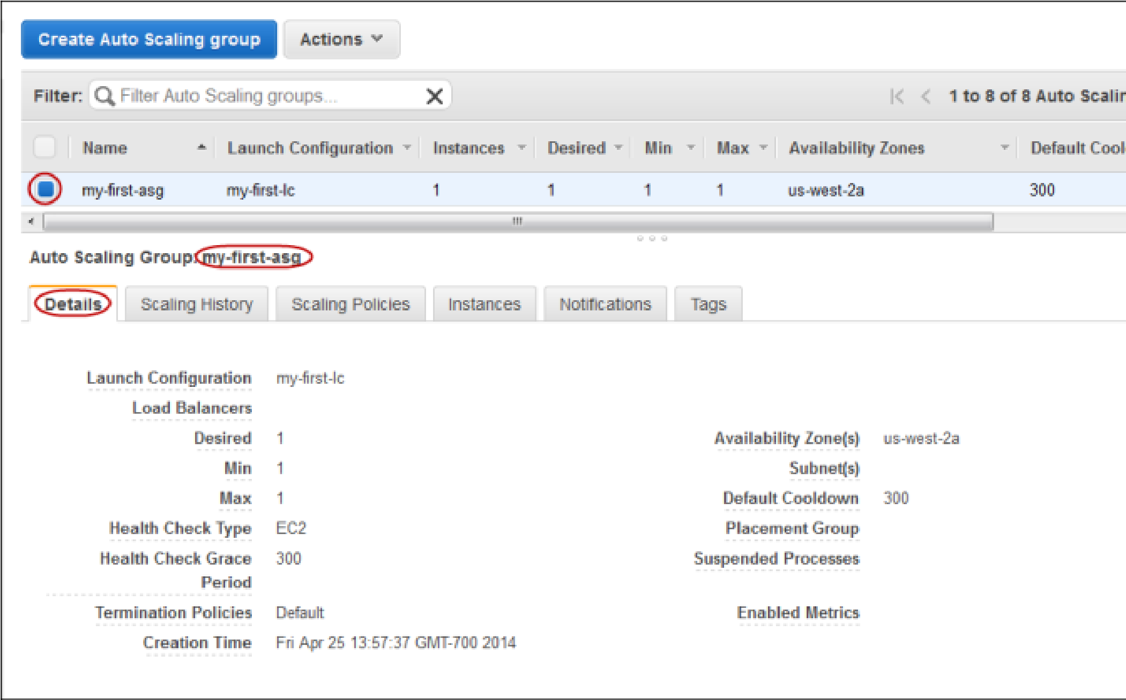Select the **Instances** tab. The **Lifecycle** column contains the state of your newly launched instance. You can see that your Auto Scaling group has launched your

EC2 instance, and it is in the InService lifecycle state. The **Health Status** column shows the result of the EC2 instance health check on your instance.

1. (Optional) If you want, you can try the following experiment to learn more about Auto Scaling. The minimum size for your Auto Scaling group is 1 instance. Therefore, if you terminate the running instance, Auto Scaling must launch a new instance to replace it.
   1. On the **Instances** tab, click the ID of the instance. This takes you to the **Instances** page and selects the instance.
   2. Click **Actions**, select **Instance State**, and then click **Terminate**. When prompted for confirmation, click**Yes, Terminate**.
   3. 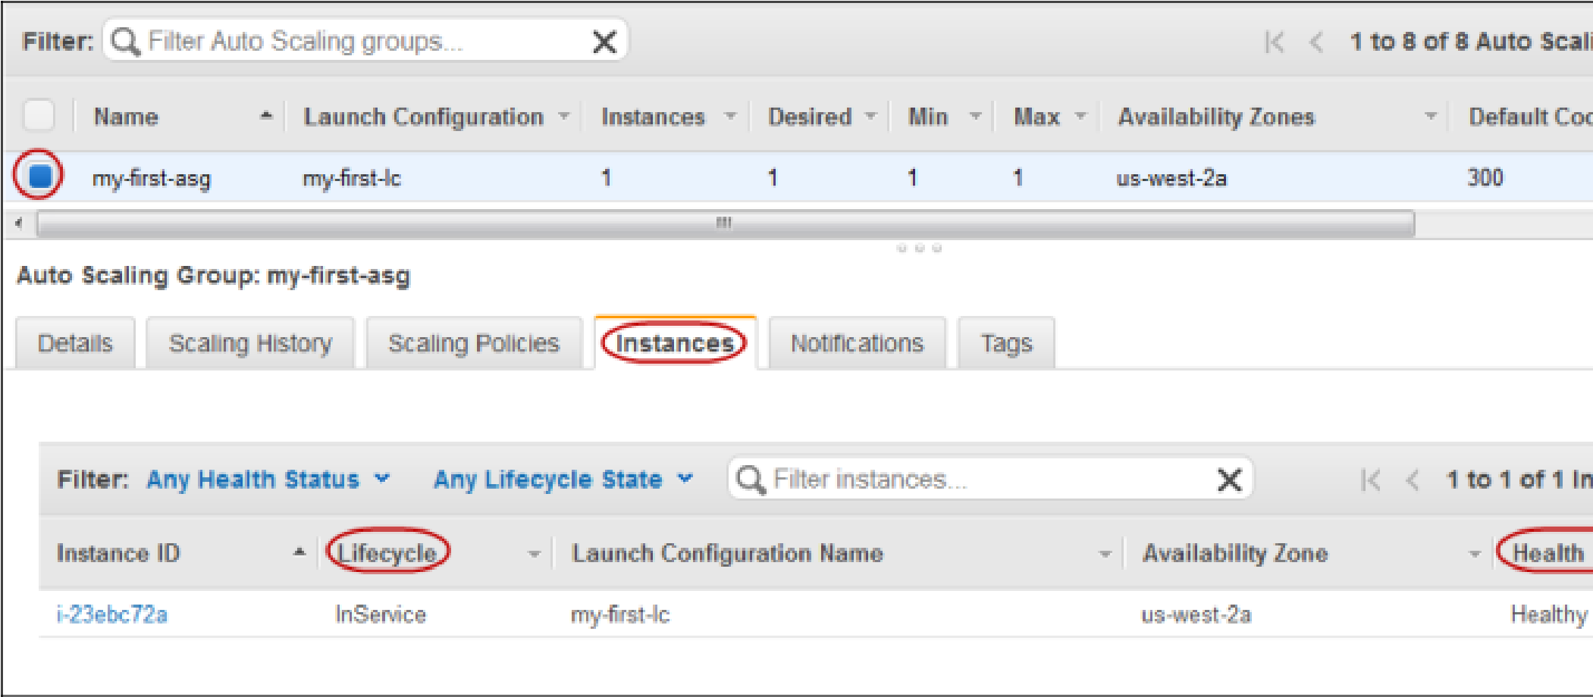In the navigation pane, select **Auto Scaling Groups** and then select the **Scaling History** tab. The default cooldown for the Auto Scaling group is 300 seconds (5 minutes), so it takes about 5 minutes until you see the scaling activity. When the scaling activity starts, you'll see an entry for the termination of the first instance and an entry for the launch of a new instance. The **Instances** tab shows the new instance only.
   4. In the navigation pane, select **Instances**. This page shows both the terminated instance and the running instance.

# Step 4: Delete Your Auto Scaling Infrastructure

You can either delete your Auto Scaling set up or delete just your Auto Scaling group and keep your launch configuration to use at a later time.

**To delete your Auto Scaling group**

1. Open the Amazon EC2 console.
2. In the navigation pane, under **Auto Scaling**, click **Auto Scaling Groups**.
3. On the Auto Scaling groups page, select your Auto Scaling group (for

example, my-first-asg).

1. Click **Actions** and then click **Delete**. When prompted for confirmation, click **Yes, Delete**.

The **Name** column indicates that the Auto Scaling group is being deleted. The **Desired**, **Min**, and **Max**columns shows 0 instances for the Auto Scaling group.

Skip this procedure if you would like keep your launch configuration.

**To delete your launch configuration**

1. In the navigation pane, under **Auto Scaling**, click **Launch Configurations**.
2. On the **Launch Configurations** page, select your launch configuration (for

example, my-first-lc).

1. Click **Actions** and select **Delete launch configuration**. When prompted for confirmation, click **Yes, Delete**.